

Which Electrical Appliances should be PAT Tested and/or Inspected?

Appliances which need testing and inspecting can vary depending on the use and environment where the item is located. The IEE Code of Practice provides a guide, but you will also need to consider the requirements of your insurance company to avoid claim issues. Further information is available on our website, or contact us to discuss your requirements.

Electrical Safety is an essential aspect of a company’s or Businesses Health & Safety Policy to ensure that staff aren’t harmed by any electrical equipment within a business premises. PAT Testing and Visual Inspections should be performed regularly to protect employees, customers and you, against any accidents and liability within the workplace. PAT Testing and Visual Inspections are carried out by us in accordance with guidelines stated in the IEE Code of Practice.
ELECTRICA

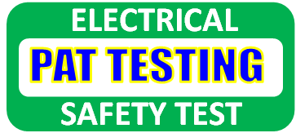
Prices (Include Vat):

Initial Call Out Fee
£22.50 Per Address

PAT Testing & Visual Inspection:
1 – 100 - £1.25 Per Item
101 – 200 - £1.00 Per Item
201 + - £0.85 Per Item

Visual Inspection Only:
£0.80 Per Item

Contact Us
Office: 01227 766415
Mobile: 07816364444
Email: pattesting@kentreusers.co.uk
www.kentreusers.co.uk

Unit 19 Barton Business Park
New Dover Road
Canterbury, Kent
CT13AA

T

